FONTS

* All fonts appear incorrect could you please make sure they are the font we provided?

POP UP RED BUTTON

* The red button on the right should read **“request call back”** and it should link to the calendar page for **all pages but the blog** **page** where it should change to **“sign up”** and should link to this page: <http://smallbizvideos.co.uk/subscribe-to-our-email-list/?preview_id=73546&preview_nonce=0161934374&_thumbnail_id=-1&preview=true>

CALENDAR PAGE

* The calendar page has disappeared
* There should be a link from each of the packages on the VIDEO PACKAGES page to the calendar page to request a call back

LOADING

* The site takes ages to load or doesn’t load at all can you look into fixing this please?

LANDING PAGE

* The video we are using as a test on the landing page appears with two black bars on each side when tested in chrome is this a problem with the video file i.e. does it need to be resized or is this a problem with the template?

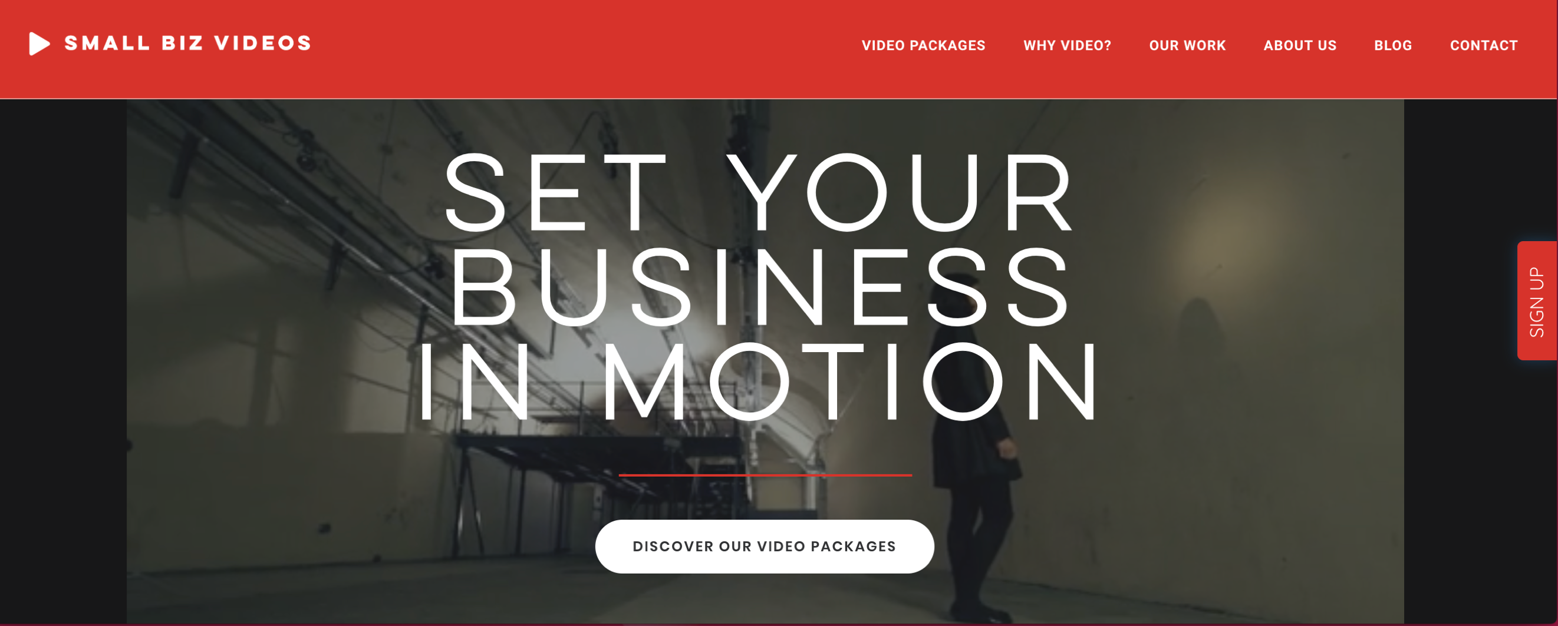

* The video doesn’t play at all when we load the site in safari or when we look at the site on mobile

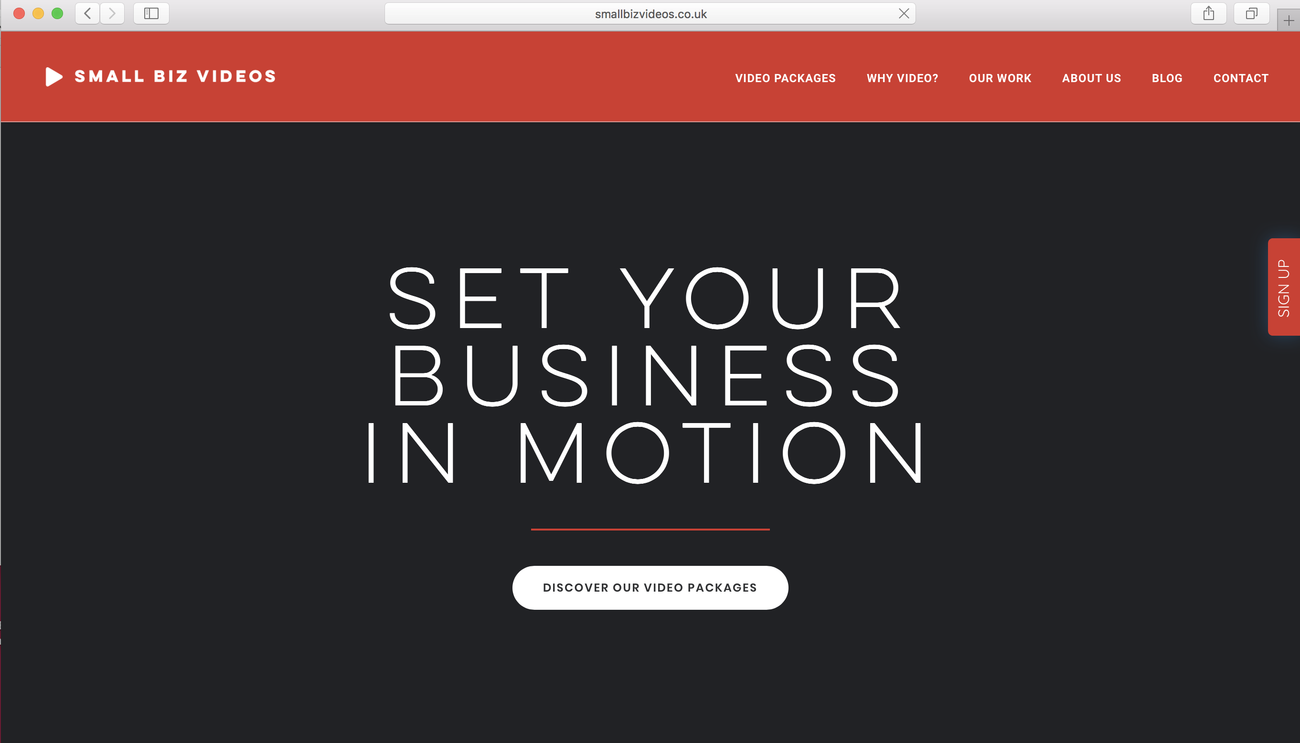

OUR WORK

* Here we need to either add an overlay on each of the video or a short description underneath to specify what package they are i.e. bronze, silver or gold. Is that possible? If not do is there another page in the template we can use to do that?

BLOG

* Would it be possible to have an individual URL for each blog category? Such as:  
  <http://smallbizvideos.co.uk/smal-biz-video-blog-posts/resources><http://smallbizvideos.co.uk/smal-biz-video-blog-posts/innovation>